IMPACT OF CONSTRUCTION DELAYS ON PROJECT COST IN THE NIGERIAN CONSTRUCTION INDUSTRY: A CASE STUDY OF AE-FUNAI

BY

UGURU JUDE NWEGEDE
2020/EN/14448

A PROJECT RESEARCH SUBMITTED IN PARTIAL FULFILMENT OF THE REQUIREMENTS FOR THE AWARD OF BARCHELOR OF ENGINEERING (B.ENG.) DEGREE IN CIVIL ENGINEERING

DEPARTMENT OF CIVIL ENGINEERING, FACULTY OF ENGINEERING AND TECHNOLOGY, ALEX EKWUEME FEDERAL UNIVERSITY, NDUFU-ALIKE, EBONYI STATE.
.

SUPERVISOR
ENGR. PROF. C.U. NWOJI

NOVEMBER, 2025.

CERTIFICATION
It is hereby certified that this project titled ‘impact of construction delays on project cost in Nigerian construction industry: A case study of Alex Ekwueme Federal University Ndufu Alike, is an original work conducted, carried out and written by Uguru Jude Nwegede with Registration Number 2020/EN/14448, in partial fulfilment of the requirements for the award of Bachelor of Engineering (B.Eng.) degree in the department of Civil Engineering, Faculty of Engineering and Technology, Alex Ekwueme Federal University Ndufu Alike, Ebonyi State.
……………………………………………. ………………………..
ENGR. PROF. C.U. NWOJI DATE
(SUPERVISOR)

……………………………………………………… ………………………….
ENGR. DR. A.O. ODUMADE DATE
(HEAD OF DEPARTMENT)

………………………………………………………. ……………………………
ENGR. PROF. CHARLES C. IKE DATE
(EXTERNAL EXAMINER)

DEDICATION
This research work is dedicated to the Almighty God, whose boundless grace, wisdom, and mercy have been the foundation of my strength and perseverance throughout the course of this academic pursuit. It is also dedicated to my esteemed parents, whose steadfast moral, spiritual, and financial support have been instrumental to my success. I further dedicate this work to Barr. Uguru Sylvester Nwokpuru and Rev. Oso David Francis, in recognition of their invaluable guidance, encouragement, and mentorship during the challenging phases of this academic journey.

ACKNOLEDGEMENT
With profound gratitude, I acknowledge the Almighty God, the source of wisdom, knowledge, and strength, for His unfailing grace, divine guidance, and protection throughout the course of this academic journey. His mercy has been my anchor, and His blessings have made the successful completion of this research possible.
I express my deepest appreciation to my mentors, Prof. Ezeora Jeremiah, Engr. Edu Chukwuma, and Rev. Fr. Augustine C. Ovia, whose invaluable guidance, encouragement, and moral support provided me with the motivation and direction necessary to accomplish this work. Their mentorship has been a great source of inspiration, both academically and personally.
My sincere gratitude also goes to my lecturers, particularly Prof. Clifford Nwoji and Engr. Okoye Oluchukwu, for their unwavering commitment to academic excellence and their fatherly advice that has prepared me to face greater challenges beyond the university walls. Their dedication and professionalism remain a model to emulate.
I am equally grateful to my colleagues, friends, and every individual who, in one way or another, contributed to the success of this research through their encouragement, prayers, and support during difficult moments.
May the Almighty God, in His infinite goodness, reward and bless you all abundantly.

TABLE OF CONTENT

CERTIFICATION i
DEDICATION ii
ACKNOLEDGEMENT iii
TABLE OF CONTENT iv
LIST OF TABLES vi
LIST OF FIGURES vii
ABSTRACT viii
CHAPTER ONE １
INTRODUCTION １
1.1. Background of study １
1.2. Statement of problem ４
1.3. Aims and objectives ５
1.4. Scope of the research ５
1.5. Significance of the study ６
1.6. Justification of the study ６
1.7. Study limitation/delimitation ７
CHAPTER TWO ９
LITERATURE REVIEW ９
2.0 Introduction ９
2.1 Conceptual Review ９
2.1.1 Construction Delays ９
2.1.2 Project Cost in Construction １２
2.1.3 Alex Ekwueme Federal University, Ndufu-Alike Ebonyi State. (AE-FUNAI) １５
2.2 Theoretical Framework １９
2.2.1 Critical Path Method (CPM) １９
2.2.2 Transaction Cost Theory (TCT) ２１
2.3 Empirical Review ２３
2.3.1 Causes of Construction Delays ２３
2.3.2 Financial Implications of Delays ２５
2.3.3 Mitigation Strategies for Construction Delays ２７
2.3.4 Impact of Construction Delays on Stakeholders ２９
2.3.5 Government Policies and Construction Delays ３１
2.4 Gap in Literature ３４
CHAPTER THREE ３６
RESEARCH METHODOLOGY ３６
3.0 Research Design ３６
3.1 Study Area ３６
3.2 Population of the Study ３７
3.3 Sampling Technique and Sample Size ３７
3. 4 Data Collection Methods ３７
3.5 Method of Data Analysis ３８
3.6 Reliability and Validity of Research Instruments ３８
3.7 Ethical Considerations ３８
CHAPTER FOUR ３９
DATA PRESENTATION, ANALYSIS AND INTERPRETATION ３９
4.0 Introduction ３９
4.1 Response rate and dataset overview ３９
4.2 Demographic profile of respondents ４０
4.3 Causes of construction delays ４２
4.4 Cost outcomes and affected cost elements ４３
4.5 Mitigation strategies reported ４４
4.6 Inferential analysis and mathematical models ４４
4.8 Summary of findings ５０
CHAPTER FIVE ５１
SUMMARY, CONCLUSION, AND RECOMMENDATIONS ５１
5.1 Summary of Findings ５１
5.2 Discussion of Findings ５２
5.3 Conclusion ５３
5.4 Recommendations ５３
5.5 Suggestions for Further Studies ５４
References ５５
APPENDIX ５８

LIST OF TABLES
Table 1: Graph of Construction Delays & Cost Overruns 1
Table 2: Project Cost in Construction Breakdown in 2025 13
Table 3: Diagram of Critical Path Method (CPM) 20
Table 4: Pie Chat of Transaction Cost Theory 22

Table 4.1: OLS Regression Results on the Impact of Construction Delays on Project Cost 45
Table 4.2: Logistic Regression Results on the Likelihood of Project Cost Increase 47

LIST OF FIGURES
Figure 1: AE-FUNAI Faculty of Arts and Humanites Road from Department of Theatre Arts To University Clinic 2
Figure 2: AE-FUNAI Abandoned Road leading from AE-FUNAI main gate to the University Staff Quarters 3
Figure 3: AE-FUNAI Faculty of Engineering Lecture Hall Delayed from
Inception to Completion 11
Figure 4: Abandoned Principal Admin Block, Beside AE-FUNAI Senate Building 16
Figure 5: Close View of Abandoned Principal Admin Block, Beside AE-FUNAI Senate Building 17
Figure 4.1: Top causes of construction delays (count of selections). 43
Figure 4.2: Proportion of respondents reporting cost increases due to delays. 43
Figure 4.3: Estimated percentage increase in project cost due to delays (midpoint values). 44

ABSTRACT
Delays in construction initiatives have come to be a pressing issue in Nigeria, affecting not just timelines but additionally escalating project charges. At Alex Ekwueme Federal University, Ndufu-Alike (AE-FUNAI), construction projects play a critical role in the university’s development and photo. However, a lot of those initiatives go through setbacks that result in price overruns, unfinished systems, and frustration amongst stakeholders. These delays are frequently related to demanding situations consisting of poor planning, late release of funds, modifications in layout all through execution, and weak supervision. This observation investigates how production delays particularly affect assignment fees within AE-FUNAI. It adopts a combined-method technique, combining responses from engineers, contractors, supervisors, and challenge consultants via questionnaires and interviews. The aim is to uncover not only the reasons for those delays but also how they translate into economic burdens, through rising hard work expenses, idle machinery, repeated procurement techniques, and prolonged overheads. Findings display that inner administrative strategies, poor conversation among stakeholders, and lack of timely choice-making significantly contribute to those delays and their value implications. They also take a look at factors to a need for more transparent budgeting, early-stage chance evaluation, and better coordination between the college and contractors. By specializing in a single group, this research gives realistic, context-precise recommendations that could be scaled up to improve production delivery in other Nigerian public universities. If carried out, these strategies could assist in reducing economic waste, accelerate infrastructure development, and enhance stakeholder delight.

CHAPTER ONE

INTRODUCTION

Background of study
The construction enterprise is a chief motive force of infrastructural growth, country-wide improvement, and employment technology in Nigeria (Aibinu & Jagboro, 2014). However, the continual trouble of assignment delays has continued to plague the world, resulting in financial burdens, incomplete structures, and diminishing public belief. In public establishments like Alex Ekwueme Federal University Ndufu-Alike (AE-FUNAI), construction delays tackle an excellent extra pressing tone, as they directly affect the group’s capability to supply first-rate training, offer adequate lodging, and meet its infrastructural improvement desires.
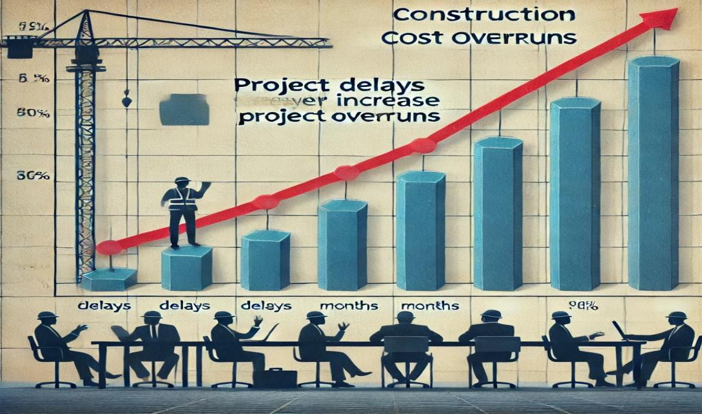
Table 1: Graph of Construction Delays & Cost Overruns
At AE-FUNAI, like in lots of different Nigerian institutions, building projects which includes lecture halls, hostels, libraries, roads and laboratories are regularly behind schedule past the scheduled timeline.
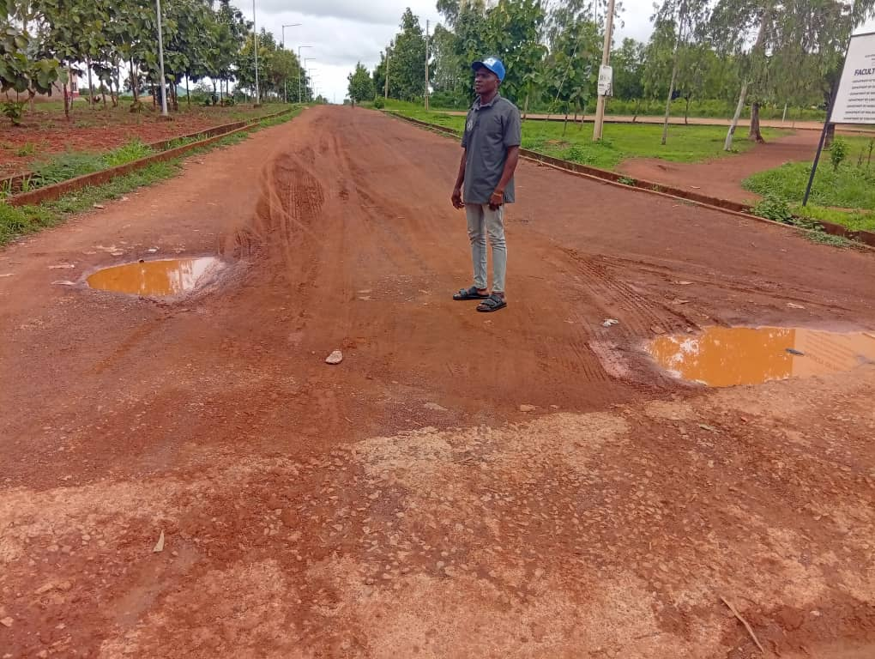
Figure 1: AE-FUNAI Faculty of Arts and Humanites Road from Department of Theatre Arts To University Clinic
These delays aren't simple administrative inconveniences; they are also financial sinkholes, main to higher creation costs because of extended hard work charges, rising prices of substances, settlement versions, and further assignment overheads (Ogbu & Olalekan, 2021). The scenario is compounded by using different challenges inclusive of inadequate project-making plans, behind-schedule fund releases, inflation, procurement hurdles, and coverage inconsistencies (Ibrahim & Musa, 2022).
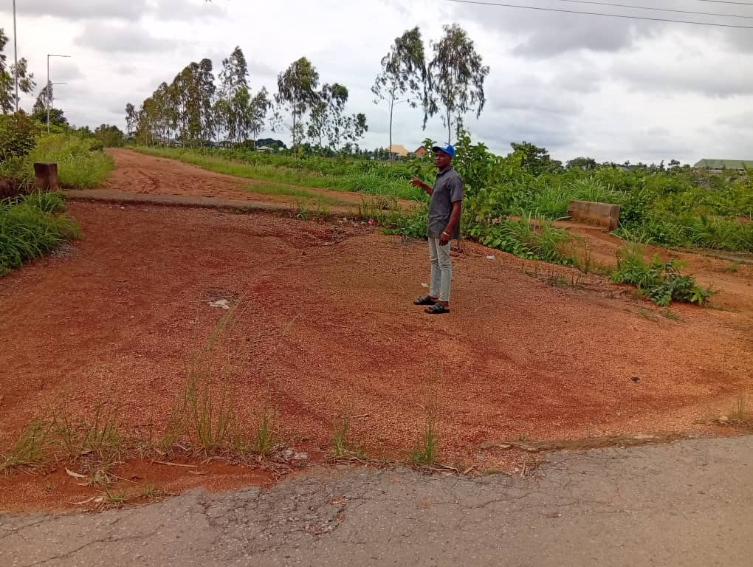
Figure 2: AE-FUNAI Abandoned Road leading from AE-FUNAI main gato to the University Staff Quarters
Several researchers have recognized the foundational reasons of these delays, bringing up issues like terrible communication between stakeholders, political and institutional bottlenecks, shifts in mission scope, and prison disputes as routine themes (Alade et al., 2023; Olusanya et al., 2019). These troubles frequently result in deserted projects or poorly done ones that fail to satisfy the intended reason, which is especially negative in a university setting wherein infrastructural efficiency helps in getting to know and research. Despite efforts to enhance production mission management practices in Nigeria, delays and their related fees remain a significant problem (Olawale & Sun, 2015).
Given the distance-accomplishing financial and developmental effects of those delays, there may be a compelling need to take a look at their impact, specially inside AE-FUNAI. This study, therefore, seeks to research how creation delays have encouraged challenge charges in the university, uncovering the underlying elements and featuring context-precise strategies to mitigate future occurrences. By doing so, the research pursues to make contributions meaningfully to the discourse on construction efficiency in Nigerian public establishments and guide informed choice-making with the aid of stakeholders, together with college control, contractors, and policymakers.

1.2. Statement of problem
In recent years, attention has steadily grown toward improving infrastructure in Nigerian universities. Yet, many construction projects continue to face frustrating and costly delays. At Alex Ekwueme Federal University Ndufu-Alike (AE-FUNAI), these delays are more than just inconveniences—they affect student life, disrupt academic activities, and stretch project budgets far beyond what was initially planned. In some cases, buildings that were meant to be completed within a year have dragged on for years, leading to increased financial commitments, new contract terms, and unforeseen costs. Although there’s already a fair amount of research on construction delays across Nigeria, very few studies have zoomed in on how these delays specifically impact public universities like AE-FUNAI. This is important because universities don’t operate like private businesses or commercial developers; they follow different administrative procedures, rely on government allocations, and often face unique challenges when it comes to funding and project execution. Because of this, the financial toll of construction delays in this context deserves focused investigation. At the heart of the problem is a lack of detailed understanding about how delays play out in the university's construction environment—and what steps can realistically be taken to reduce their impact. Without this knowledge, the cycle of slow progress, rising costs, and incomplete buildings is likely to continue. This research aims to fill that gap by closely examining how delays affect project costs at AE-FUNAI and by offering insights that can help guide better planning, budgeting, and execution in future projects.

1.3. Aims and objectives
The primary aim of this study is to assess the impact of construction delays on project costs in AE-FUNAI, with the following objectives:
- To identify the major causes of construction delays in AE-FUNAI projects.
- To analyze the cost implications of construction delays within the institution.
- To examine the relationship between delay duration and financial overrun.
- To propose practical mitigation strategies to reduce delays and cost overruns in future projects.

1.4. Scope of the research
This study is specifically limited to construction projects initiated and executed within Alex Ekwueme Federal University Ndufu-Alike (AE-FUNAI), located in Ebonyi State, Nigeria. It focuses on selected infrastructural developments within the institution, such as lecture halls, hostel blocks, laboratories, administrative offices, and related facilities. These projects, both completed and ongoing, serve as the basis for examining how construction delays have impacted overall project costs. Rather than taking a broad, nationwide approach, this research narrows its attention to the unique environment of a public university setting, where funding structures, project supervision, and timelines are influenced by government procedures and academic needs. The study excludes projects outside AE-FUNAI and does not consider delays unrelated to construction, such as administrative or academic calendar disruptions. By keeping the focus within the bounds of AE-FUNAI, this research offers a more precise and in-depth understanding of the cost implications of construction delays within the context of tertiary education infrastructure. It also explores how internal factors—like institutional management styles, contractor efficiency, and regulatory oversight—contribute to these delays.

1.5. Significance of the study
This study holds particular significance for several key players within the university and the broader construction industry. First, it offers practical insights for AE-FUNAI’s management, project supervisors, and planning committees on how construction delays affect project costs—and how these challenges can be better managed moving forward. Understanding the financial consequences of delays within the university context can help ensure smarter budgeting, tighter supervision, and better prioritization of resources. For government bodies and education-sector policymakers, the research provides evidence-based recommendations for improving regulations, project monitoring, and funding structures—especially for federal institutions. Contractors and construction consultants working within academic environments like AE-FUNAI will also benefit from this study by gaining a clearer picture of common delay triggers and the financial ripple effects they cause. Lastly, this study contributes to academic literature by focusing on a relatively underexplored area: the cost impact of project delays in the setting of a Nigerian federal university. It offers a localized but meaningful contribution that can inform both future research and practical project execution.

1.6. Justification of the study
This study is justified by its potential to offer meaningful, practical solutions to the persistent issue of construction delays—specifically within the context of Alex Ekwueme Federal University, Ndufu-Alike (AE-FUNAI). While many previous studies have examined the causes of construction delays across Nigeria, few have paid close attention to their direct financial implications within a university setting, or how to proactively prevent them. As AE-FUNAI continues to expand its infrastructure to meet the demands of a growing academic community, the ability to deliver projects on time and within budget becomes even more critical. By exploring how construction delays impact project costs on campus, this study aims to help the university avoid unnecessary financial losses and improve the overall efficiency of its building projects. The findings will also support policymakers and administrators in making better-informed decisions around planning, budgeting, and supervision. Furthermore, the study contributes to the broader body of research in construction management by offering empirical insights tailored to a Nigerian federal university—something that remains relatively underexplored in academic circles. Ultimately, this work hopes to empower contractors, university management, and regulatory authorities with strategies that not only reduce delays but also safeguard the financial integrity of future construction efforts at AE-FUNAI.

1.7. Study limitation/delimitation
While this research presents meaningful insights into the impact of construction delays on project costs, particularly within AE-FUNAI, it is not without limitations. One of the major challenges is the limited availability of detailed financial data from construction firms and project handlers. Not all stakeholders may be willing to share cost-related records or admit to shortcomings in project execution. This lack of transparency may affect the completeness of data collected. Moreover, the study is confined to infrastructure projects within AE-FUNAI, which, while significant, may not fully reflect the realities of construction dynamics in rural settings or even other Nigerian universities. Economic instability, political events, or unplanned crises such as the COVID-19 pandemic can also influence project timelines, but these external shocks fall outside the primary scope of this research. Delimitations of this study include a deliberate focus on large-scale public infrastructure projects such as academic buildings, hostels, and road networks within AE-FUNAI. Small-scale residential or private constructions are excluded to ensure the research remains relevant to institutional development planning. Additionally, due to time and logistical constraints, only selected projects and stakeholders will be analyzed, which may limit the extent of generalization. Nonetheless, the findings are expected to offer valuable guidance for similar environments and contribute to improving construction management practices within academic institutions.

CHAPTER TWO

LITERATURE REVIEW

2.0 Introduction
The literature review presents an extensive analysis of previous research on construction delays and their financial implications, with a particular emphasis on the Nigerian construction sector. This chapter explores key terminologies, theoretical models, and empirical evidence, providing a solid foundation for the current study. It critically assesses the prevailing causes, consequences, and mitigation strategies associated with construction delays while identifying gaps in existing research. By reviewing prior works, this chapter establishes a comprehensive framework that justifies the need for further investigation into the financial and operational consequences of construction delays, thereby contributing to academic and practical advancements in the field.

2.1 Conceptual Review

2.1.1 Construction Delays
Construction delays are a common yet critical challenge in the industry, often disrupting project timelines and leading to severe financial and reputational consequences for stakeholders. A delay occurs when a project extends beyond its planned completion date due to various internal and external factors. These delays not only inflate project costs but also strain relationships among contractors, clients, and project financiers, sometimes culminating in legal battles and loss of credibility. Construction delays at AE-FUNAI, like in most public universities in Nigeria, are often multifaceted. Scholars such as C.U. Nwoji, in a study on building maintenance within Nigerian universities, highlight that delayed construction and poor maintenance culture are interrelated issues that stem from inadequate funding, bureaucratic inefficiencies, and weak project supervision (Ugwu, Okafor & Nwoji, 2018). These challenges, if not promptly addressed, gradually evolve into structural degradation, rising costs, and diminished functionality of built structures.
According to Akinsiku and Akintoye (2019), several factors contribute to delays in construction projects, ranging from poor initial planning and inefficient resource allocation to supply chain bottlenecks and unforeseen site conditions. Delays can be broadly classified into two categories: excusable delays and non-excusable delays.
- Excusable Delays: These delays are often beyond the control of project stakeholders and arise from unpredictable external factors. Examples include adverse weather conditions, changes in government policies or regulations, unexpected site conditions (such as the discovery of archaeological remains or hazardous materials), and natural disasters like floods or earthquakes. Since these delays are unforeseen, contractors may not be held directly responsible, and project timelines can be adjusted accordingly through contract extensions.
- Non-Excusable Delays: These result from managerial inefficiencies, inadequate financial planning, procurement failures, and poor coordination among project teams. Such delays are preventable and are often caused by lack of proper scheduling, delays in material supply, labor shortages, design errors, or miscommunication among stakeholders. Unlike excusable delays, non-excusable delays usually lead to penalties, additional costs, and strained contractual relationships.
In many cases, delays are compounded by multiple factors, making it difficult to pinpoint a single cause. For instance, a project that is already experiencing procurement delays may face additional setbacks due to a sudden change in government import policies affecting material availability. Similarly, poor site management can exacerbate the impact of unexpected weather conditions, further pushing the completion date.
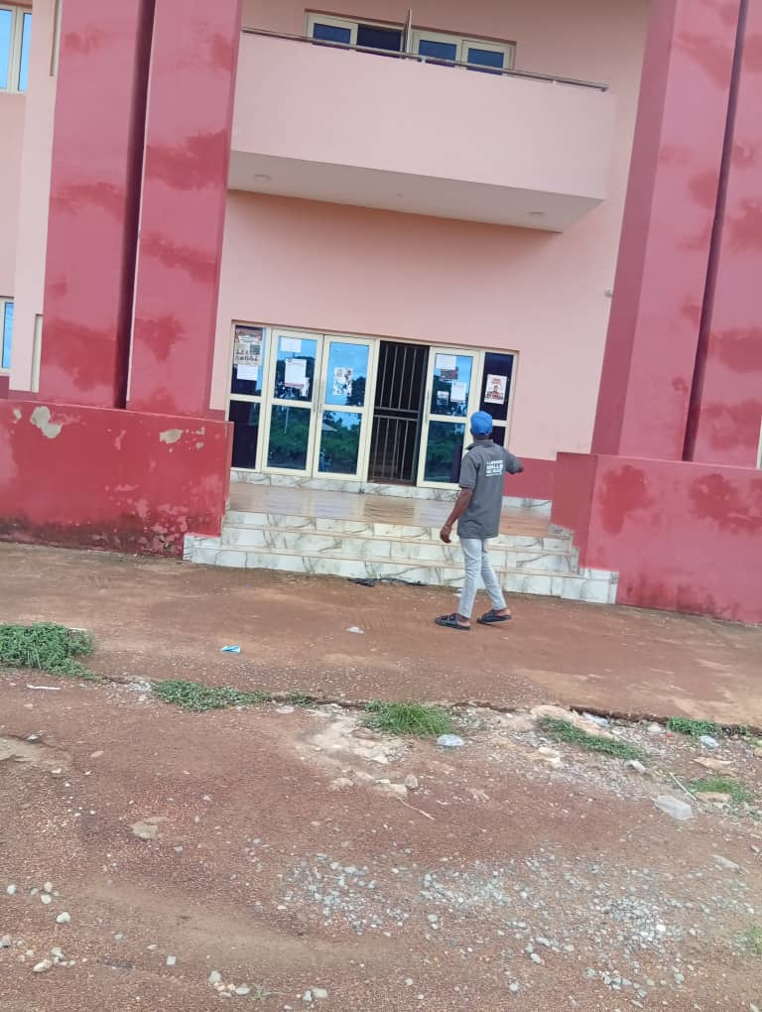
Figure 3: AE-FUNAI Faculty of Engineering Lecture Hall Delayed from Inception to Completion
The effects of construction delays are far-reaching. Financially, prolonged projects lead to increased overhead costs, extended labor payments, and potential liquidated damages for failing to meet contract deadlines. Clients may also suffer losses due to delayed occupancy or operational startup, especially in commercial projects where time-to-market is crucial. Furthermore, prolonged delays can erode trust in construction firms, reducing their chances of securing future projects.
To mitigate these issues, proactive project management strategies are essential. This includes adopting effective scheduling techniques like the Critical Path Method (CPM), ensuring adequate financial planning, strengthening supply chain management, and leveraging technology for real-time project monitoring. Additionally, clear contractual terms that outline delay provisions and risk-sharing mechanisms can help in managing disputes and ensuring that all parties remain accountable throughout the project lifecycle.
By understanding the complexities of construction delays and addressing their root causes, industry professionals can work towards delivering projects on time, within budget, and to the expected quality standards.

2.1.2 Project Cost in Construction
Project cost in construction refers to the total financial resources required to plan, execute, and complete a project. It is a crucial factor in project management, as cost overruns can significantly impact profitability, delay project timelines, and lead to contractual disputes. Proper budgeting and cost control are essential to ensuring that a construction project remains financially viable from inception to completion.
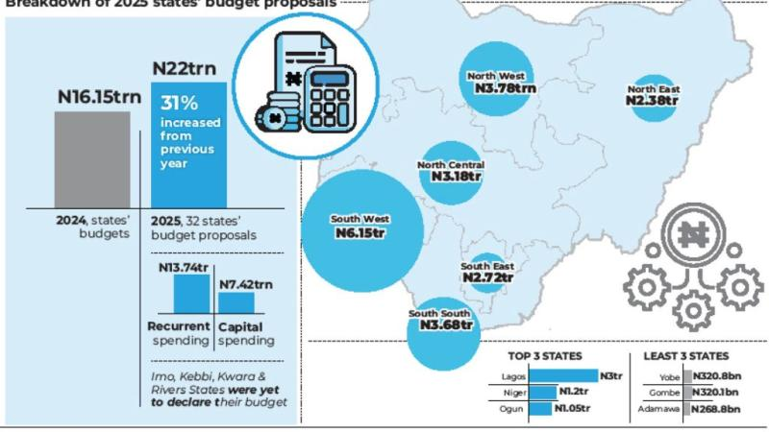
Table 2: Project Cost in Construction Breakdown in 2025
A project’s cost structure typically comprises three main components:
- Direct Costs: These are expenses that can be directly traced to the construction activities, such as the cost of materials (cement, steel, bricks, and other construction inputs), labor wages, and equipment rentals or purchases. Since direct costs form the bulk of construction expenditures, fluctuations in material prices or labor shortages can significantly impact overall project costs.
- Indirect Costs: These include administrative expenses, government permits, overhead costs, insurance, and other expenses that are not directly tied to the physical construction process but are essential for the project's execution. For example, site offices, legal fees, and safety compliance costs fall under indirect costs.
- Contingency Reserves: These are funds set aside to cover unexpected expenses that may arise due to unforeseen circumstances such as weather-related delays, regulatory changes, or sudden increases in material costs. A well-planned contingency fund ensures that minor disruptions do not derail the entire project.
One of the biggest challenges in construction cost management is cost overruns, which occur when actual expenditures exceed the initial budget. According to Adeyemi (2021), cost overruns in construction projects are often caused by inflation, project delays, frequent design modifications, and unexpected site conditions. Poor financial planning, inefficient procurement processes, and contractor mismanagement can also contribute to cost overruns.
Construction delays, in particular, have severe cost implications. When a project is delayed, several financial burdens arise, including:
- Increased Material Prices: Due to inflation and market fluctuations, construction materials tend to increase in cost over time. Delays mean that previously budgeted amounts may no longer be sufficient to procure necessary materials, forcing project managers to either adjust the budget or seek alternatives.
- Extended Labor Wages: Construction workers and specialists are typically paid based on time and contract duration. A delay in project completion means additional labor costs, as workers must remain on-site for a longer period than originally planned. This can be especially costly in large-scale projects requiring skilled labor, where daily wages can be substantial.
- Higher Interest on Project Loans: Many construction projects are financed through bank loans or investor funding, which accrue interest over time. Delays prolong the repayment period, increasing the overall interest burden on the project. In some cases, loan terms may need to be renegotiated, leading to additional financial complications.
- Penalties for Late Delivery: Construction contracts often include penalty clauses for late completion. Clients may impose fines or liquidated damages for each day a project extends beyond the agreed deadline. These penalties can significantly reduce a contractor’s profit margin and, in extreme cases, lead to legal disputes.
- Potential Litigation Costs: When delays cause financial loss or breach of contract, legal action may be taken by stakeholders, leading to court fees, settlement costs, and reputational damage. Disputes between contractors, suppliers, and clients over cost escalations can also contribute to further delays and financial losses.
Given these challenges, effective cost management strategies are necessary to ensure that projects remain within budget. Implementing robust financial planning, conducting detailed risk assessments, and integrating technology-driven project management tools can help mitigate unforeseen expenses. Additionally, clear communication and well-structured contracts that outline cost responsibilities can prevent conflicts and ensure accountability among project stakeholders.
In the dynamic and often unpredictable construction industry, maintaining tight control over project costs is vital to ensuring sustainability, profitability, and timely project delivery.

2.1.3 Alex Ekwueme Federal University, Ndufu-Alike Ebonyi State. (AE-FUNAI)
The Alex Ekwueme Federal University, Ndufu-Alike (AE-FUNAI), located in Ebonyi State, stands as one of the fastest-growing tertiary institutions in Nigeria, with a vision of becoming a world-class institution anchored on excellence, innovation, and global competitiveness. Since its establishment in 2011, the university has embarked on a series of construction projects aimed at meeting the infrastructural demands of a rapidly increasing student and staff population. These projects include the construction of lecture theatres, laboratories, departmental buildings, staff quarters, students’ hostels, internal roads, and water supply systems, all integral to the smooth functioning and academic growth of the institution.
However, despite the university's noble aspirations, many of its construction projects have faced significant delays, which in turn have resulted in cost overruns, missed academic timelines, and stakeholder dissatisfaction. These delays are not isolated incidents, but rather symptomatic of broader issues prevalent in Nigeria’s public-sector construction environment. According to Ugwu, Okafor, and Nwoji (2018), construction activities within Nigerian universities are often hampered by poor planning, delayed fund releases, lack of contractor capacity, and weak institutional monitoring systems.
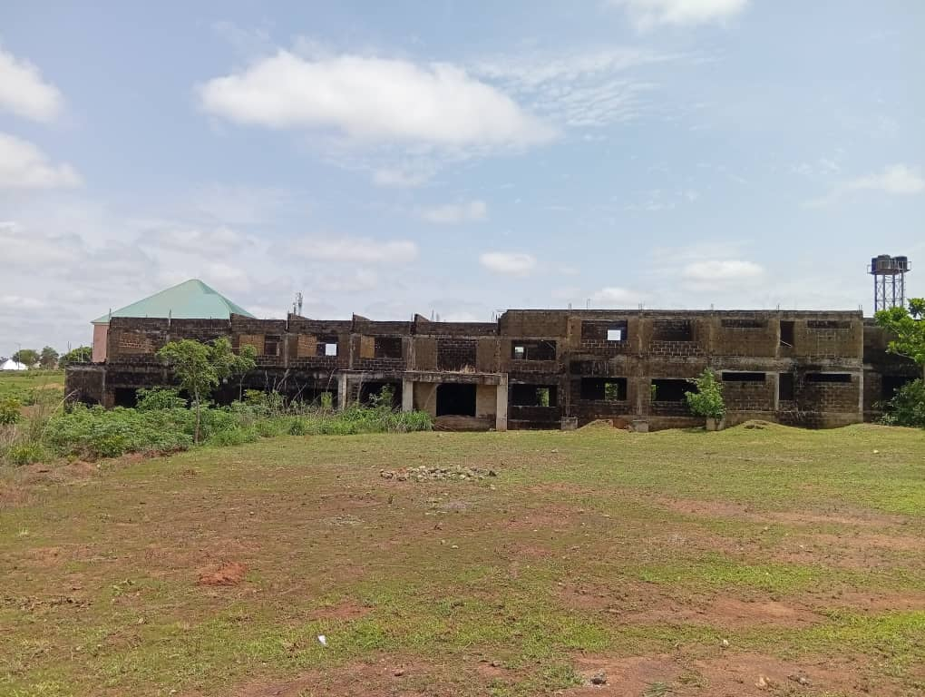
Figure 4: Abandoned Principal Admin Block, Beside AE-FUNAI Senate Building
AE-FUNAI provides a vivid example of how construction delays can ripple through an institution’s ecosystem. For instance, the delay in the completion of major classroom blocks and staff offices in certain faculties has led to overcrowding, strained timetables, and discomfort among students and lecturers. In some cases, students have been taught under temporary canopies or shared facilities between departments. Furthermore, delayed student hostels have forced many undergraduates to seek off-campus accommodations under less secure and more expensive conditions.
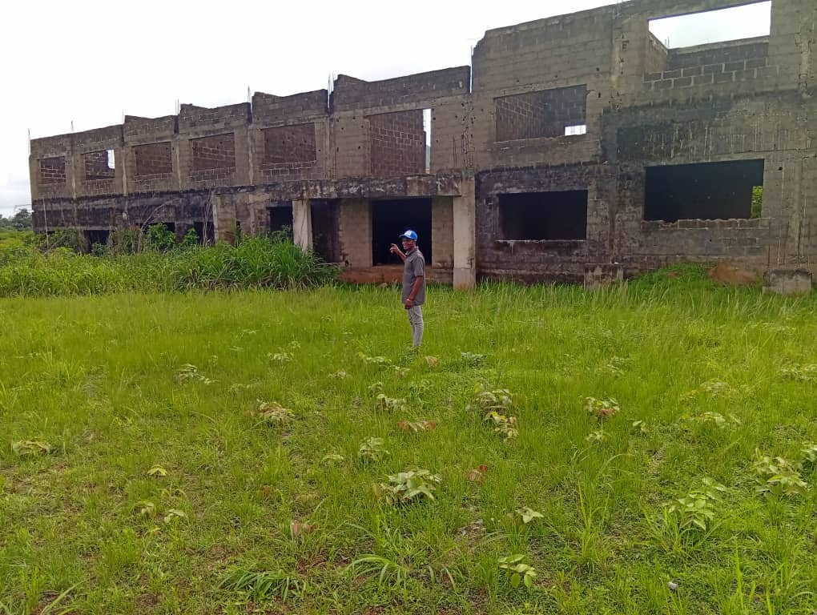
Figure 5: Close View of Abandoned Principal Admin Block, Beside AE-FUNAI Senate Building
These issues affect not just the learning environment, but also the university’s reputation, staff morale, and overall institutional credibility.
From a financial perspective, delays in AE-FUNAI’s construction projects often lead to cost escalation, as the prices of building materials and labor rise over time. For example, a project that was budgeted in 2021 may become significantly more expensive by 2023 due to inflation and changes in market rates. Omoregie and Radford (2006) assert that such delays commonly lead to contractual variations, revaluation of projects, and additional costs not originally anticipated. This is particularly troubling for government-funded institutions like AE-FUNAI, which rely heavily on allocated funds from the Federal Government or intervention agencies like TETFund. When projects stall due to delayed payments or contractor inefficiencies, the university is often forced to renegotiate contracts or seek supplementary budgets, further prolonging completion.
Another major contributor to construction delays at AE-FUNAI is procurement bureaucracy. As with many public institutions, the university follows the Public Procurement Act which, though designed to ensure transparency and accountability, often slows down the speed at which approvals, fund disbursements, and contract mobilizations take place. This challenge aligns with Akinsiku and Akintoye’s (2019) findings that procedural bottlenecks are key delay factors in Nigerian construction projects, especially in public institutions.
There is also a growing concern regarding project monitoring and supervision. While AE-FUNAI does have a physical planning and development unit responsible for overseeing construction projects, the effectiveness of this unit is often constrained by logistical limitations and manpower shortages. Without real-time oversight, small delays in one phase of a project can snowball into larger setbacks. C.U. Nwoji, who has written extensively on building maintenance and infrastructural development in Nigerian universities, emphasizes the importance of proactive supervision and timely evaluation as tools for minimizing delays and reducing their financial impacts (Ugwu et al., 2018).
Despite these challenges, AE-FUNAI has made some commendable efforts in recent years to improve its project management processes. Some new projects have embraced modern tracking tools and adopted performance-based contracts that link contractor payments to milestone achievements. Nonetheless, the persistent recurrence of delays suggests the need for deeper reforms in the planning, procurement, and execution phases of construction in the university. In conclusion, AE-FUNAI's experience with construction delays serves as a microcosm of the Nigerian public-sector construction industry. The implications of such delays — in terms of cost, time, and institutional development — cannot be ignored. A thorough understanding of these challenges is vital for recommending more effective project delivery systems, not just for AE-FUNAI, but for similar institutions across the country.

2.2 Theoretical Framework

2.2.1 Critical Path Method (CPM)
The Critical Path Method (CPM) was developed in the late 1950s by Morgan R. Walker of DuPont and James E. Kelley Jr. of Remington Rand. It is a project management technique that identifies the longest sequence of dependent activities in a project, referred to as the critical path. These tasks determine the shortest possible completion time for the entire project, meaning any delay in these critical tasks directly extends the overall project duration. Given its ability to pinpoint essential project activities, CPM is widely regarded as an effective tool for minimizing construction delays and ensuring timely project delivery.
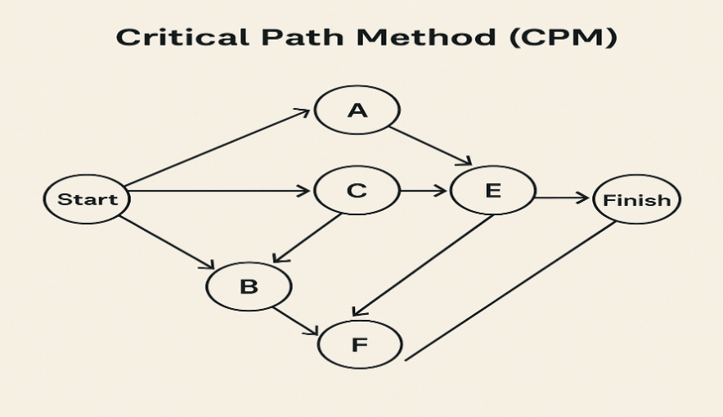
Table 3: Diagram of Critical Path Method (CPM)
One of the major advantages of CPM is its structured approach to project scheduling, which provides a clear framework for managing tasks and timelines. It helps project managers identify tasks that are crucial for meeting deadlines, ensuring that resources are allocated efficiently to avoid unnecessary delays. Additionally, CPM reduces project risks by highlighting potential bottlenecks, allowing managers to take preventive measures. However, despite its effectiveness, CPM has certain limitations. Its accuracy heavily depends on precise data input, meaning any errors in task estimation can lead to flawed scheduling. Furthermore, in its basic form, CPM does not account for resource constraints, which can make it less adaptable to real-world project challenges. Moreover, for large-scale projects with numerous dependencies, applying CPM can be complex and time-consuming.
CPM has been extensively applied in various industries, including construction, engineering, and manufacturing. For example, a study by Aibinu and Jagboro (2002) utilized CPM to evaluate delays in Nigerian construction projects, revealing that critical activities often suffer from poor financial planning and material shortages. Similarly, Alaghbari et al. (2007) applied CPM to analyze delay trends in Malaysia’s construction sector, demonstrating its effectiveness in identifying high-risk project phases and improving scheduling efficiency. These applications highlight the practical benefits of CPM in managing project timelines and mitigating delays.
In the Nigerian construction industry, CPM is particularly relevant for identifying project activities that are prone to delays and cost overruns. By applying CPM principles, this research seeks to analyze how poor scheduling and inadequate project planning contribute to financial losses and extended completion times. Additionally, the study will explore how implementing CPM can help mitigate such delays, ensuring more efficient cost management and timely project execution. Through this approach, the research aims to provide practical recommendations for improving project scheduling and overall construction management in Nigeria.

2.2.2 Transaction Cost Theory (TCT)
Transaction Cost Theory (TCT) was introduced by Ronald Coase in 1937 and later expanded by Oliver Williamson in 1979. The theory examines the costs incurred in economic exchanges, including negotiation, enforcement, and monitoring costs. In the construction industry, these transaction costs manifest in various ways, such as contractual disputes, procurement inefficiencies, poor coordination, and regulatory delays. These factors can significantly impact project timelines, budgets, and overall efficiency, making the understanding and management of transaction costs crucial for successful project execution.

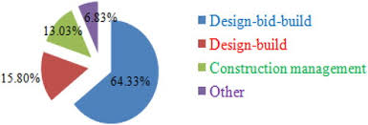
Table 4: Pie Chat of Transaction Cost Theory
One of the key merits of TCT is its ability to provide insight into the financial implications of contractual inefficiencies, helping organizations optimize procurement and supply chain management. The theory also promotes transparency and accountability in project execution, ensuring that all stakeholders are aware of the financial and operational risks involved. However, despite its usefulness, TCT has certain limitations. Accurately quantifying transaction costs can be challenging, as many of these costs are not explicitly recorded or easily measurable. Additionally, the theory primarily focuses on economic costs, often overlooking social or technical factors that may also influence project outcomes. Moreover, it may not fully capture the complexities of large-scale infrastructure projects, where multiple stakeholders and unpredictable external factors play a significant role.
TCT has been widely applied in construction-related studies to assess the impact of contract complexities and inefficiencies. For example, Bajari and Tadelis (2001) investigated how intricate contract structures contribute to increased transaction costs in the U.S. construction industry. Similarly, in Nigeria, Ojo and Akinola (2019) utilized TCT to analyze the financial burden of contractual inefficiencies in public infrastructure projects, revealing that poor contract management accounted for up to 25% of total project costs. These studies highlight the relevance of TCT in understanding financial losses resulting from ineffective project governance.
This research applies TCT to evaluate how inefficiencies in project procurement, contract administration, and stakeholder coordination contribute to construction delays and cost overruns in Nigeria. By assessing transaction costs linked to poor project execution, this study aims to provide recommendations for improving financial management, enhancing transparency, and reducing economic losses in the construction sector. Through this approach, the research will contribute to developing more effective strategies for mitigating transaction costs and ensuring the timely and cost-efficient completion of infrastructure projects.

2.3 Empirical Review

2.3.1 Causes of Construction Delays
Construction delays are a persistent challenge in the industry, leading to financial losses, project abandonment, and strained relationships among stakeholders. Several studies have examined the root causes of these delays, particularly in Nigeria, where infrastructural development is often hindered by multiple systemic issues.
According to Olanrewaju and Anavhe (2020), one of the primary causes of construction delays is poor project financing. Many construction projects experience funding shortages due to delayed payments from clients, inadequate financial planning, or difficulties in securing loans. When financial resources are not readily available, procurement of materials, payment of workers, and general project execution become sluggish, leading to inevitable delays.
Government bureaucracy is another significant factor affecting construction timelines. Securing permits, obtaining approvals, and navigating regulatory requirements can take an extended period due to inefficiencies in government agencies. Lengthy approval processes for land acquisition, environmental impact assessments, and building permits can stall projects before they even begin.
In addition to financial and bureaucratic hurdles, inadequate labor skills contribute to delays in project execution. Construction requires skilled professionals such as engineers, architects, and technicians, but the industry often struggles with a shortage of well-trained workers. When laborers lack the necessary expertise, errors increase, rework becomes frequent, and project schedules are disrupted. Similarly, weak regulatory enforcement exacerbates delays in construction. Olanrewaju and Anavhe (2020) noted that building codes and safety regulations are not always strictly enforced, leading to substandard work that eventually requires corrections. The lack of accountability among contractors and project managers often results in a disregard for timelines, causing prolonged delays. Ibrahim and Musa (2022) identified material shortages as another critical issue affecting construction progress. The unavailability of essential construction materials such as cement, steel, and aggregates can halt work indefinitely. Supply chain disruptions caused by transportation issues, import restrictions, and inflation further contribute to delays. The volatility of material prices can also force contractors to pause projects while waiting for costs to stabilize. Inefficient contract administration is another factor that affects construction timelines. Poorly drafted contracts, unclear project scopes, and disputes over payment terms often lead to misunderstandings and project interruptions. Contractual disagreements between clients and contractors, or between contractors and subcontractors, can stall construction activities for weeks or even months. Another prevalent cause of delays is frequent design modifications. When project designs are constantly altered, it disrupts workflow and necessitates additional time for re-planning, approvals, and execution. Ibrahim and Musa (2022) observed that design changes often occur due to evolving client preferences, unforeseen site conditions, or errors in the initial design phase. Each modification adds extra time and costs to the project, sometimes leading to significant setbacks. Beyond these technical and administrative factors, broader socio-political and infrastructural challenges further contribute to delays. Corruption in the construction industry often results in misallocation of funds, bribery in contract awards, and manipulation of project timelines. Political interference in construction projects can also cause unnecessary disruptions, especially when leadership changes affect funding priorities. Political instability is another major issue, as changes in government policies or economic conditions can lead to sudden project halts. Infrastructure projects often require long-term commitments, but political transitions sometimes lead to project cancellations, delays, or renegotiations. Lastly, unreliable power supply poses a serious obstacle to construction activities in Nigeria. Many construction sites rely on electricity to operate machinery, mix concrete, and run essential site operations. Frequent power outages force contractors to depend on expensive alternative energy sources like diesel generators, which increase project costs and slow down progress.

2.3.2 Financial Implications of Delays
Construction delays have significant financial consequences, often resulting in cost overruns, increased liabilities, and reduced profitability. Empirical research has consistently shown a strong correlation between project delays and financial losses, making it a critical concern for contractors, developers, and investors. Adeyemi (2021) conducted an extensive study analyzing 50 delayed construction projects in Nigeria and found that cost overruns ranged from 15% to 60% of the original project budget. These findings underscore the severe financial strain that prolonged project timelines impose on stakeholders. When projects extend beyond their scheduled completion dates, additional expenses accumulate, affecting overall financial feasibility.
One of the most immediate financial impacts of construction delays is the escalation of labor costs. Since workers must remain on-site for a longer duration than initially planned, contractors incur higher expenses in wages, overtime payments, and employee benefits. The longer a project is delayed, the more funds are required to sustain the workforce, leading to unplanned financial burdens. Inflation-induced material price hikes are another major factor contributing to cost overruns. Ogbu and Olalekan (2021) highlighted that construction materials such as cement, steel, and timber are highly susceptible to price fluctuations. A delay of several months or years can lead to significant price increases, forcing contractors to spend more than originally estimated. This is particularly problematic in economies with volatile inflation rates, where material costs can surge unexpectedly. Interest accumulation on project loans is also a significant financial implication of delays. Many construction projects are financed through loans, and delayed completion means prolonged repayment periods. The longer a project remains unfinished, the more interest accumulates, increasing the overall debt burden. For large-scale infrastructure projects, these extended loan repayment periods can translate into millions of naira in additional financial obligations. Public infrastructure projects are particularly vulnerable to financial repercussions when delays occur. In government-funded projects, prolonged construction timelines often lead to increased taxpayer burdens, as governments may need to allocate additional funds to complete stalled projects. This not only strains public finances but can also lead to project abandonment if additional funding is not secured. Furthermore, delays in public infrastructure projects tend to reduce investor confidence. When investors observe frequent project disruptions and financial mismanagement, they become hesitant to commit funds to future developments. This can slow down economic growth, as private sector participation in large-scale infrastructure investments declines.
Additionally, contractors may face penalties for late delivery, particularly in projects with strict contractual agreements. Many construction contracts include clauses that impose fines or liquidated damages on contractors for failing to meet completion deadlines. These penalties can significantly erode profit margins and, in some cases, lead to legal disputes or contract termination.
Beyond direct financial costs, delayed projects often result in opportunity costs. When a construction firm is tied up with an unfinished project, it may lose the chance to take on new projects, limiting revenue generation. Developers and property owners also experience lost income opportunities, as delayed commercial or residential buildings cannot be leased or sold as planned.

2.3.3 Mitigation Strategies for Construction Delays
Construction delays can have severe financial and operational consequences, making it essential to implement effective mitigation strategies. Scholars and industry experts have explored various approaches to minimizing these delays, focusing on proactive planning, technological advancements, and regulatory enforcement. Akinsiku and Akintoye (2019) emphasize the importance of comprehensive project planning as a fundamental strategy for preventing delays. They argue that inadequate planning often leads to inefficient resource allocation, scheduling conflicts, and unforeseen challenges that prolong project completion. By conducting thorough feasibility studies, defining clear project scopes, and establishing realistic timelines, construction firms can significantly reduce the likelihood of delays. Strict regulatory compliance is another crucial strategy in mitigating construction delays. Many projects are stalled due to legal and bureaucratic hurdles, such as delays in obtaining permits, environmental assessments, and government approvals. Ensuring compliance with relevant regulations from the outset can prevent project interruptions and costly legal battles. Enhancing workforce training and skill development is also vital. Akinsiku and Akintoye (2019) highlight that delays often arise due to low-skilled labor, which results in poor workmanship, rework, and inefficiencies. Providing continuous training programs, certifications, and skill enhancement workshops can improve workers' productivity and reduce errors that contribute to project delays. Olanrewaju and Anavhe (2020) advocate for leveraging digital project management tools to improve communication and coordination among stakeholders. Delays often stem from miscommunication, lack of transparency, and inefficient workflow management. By utilizing cloud-based collaboration platforms, real-time updates can be shared among contractors, suppliers, engineers, and project managers, ensuring that everyone remains informed and aligned with project goals. One of the most promising innovations in delay mitigation is the integration of Building Information Modeling (BIM) and artificial intelligence (AI)-driven scheduling tools. BIM allows project managers to visualize construction phases, anticipate potential challenges, and optimize workflows before physical construction begins. AI-powered scheduling tools analyze historical project data to predict potential delays and suggest alternative scheduling approaches to maintain project momentum. These technologies enhance proactive decision-making, reduce errors, and improve overall project efficiency. In addition to technological solutions, risk assessment models play a critical role in minimizing construction delays. By identifying and evaluating potential risks, such as supply chain disruptions, labor shortages, and weather uncertainties, project managers can develop contingency plans to address these challenges before they escalate. Implementing risk mitigation frameworks ensures that projects remain resilient in the face of unforeseen obstacles.
Furthermore, effective contract management can help mitigate delays. Well-structured contracts should clearly outline project timelines, responsibilities, and penalties for non-compliance. Incorporating performance-based incentives can also motivate contractors and workers to meet deadlines without compromising quality. Early procurement and supply chain optimization are additional strategies to prevent material shortages, a common cause of construction delays. Establishing strong relationships with reliable suppliers, pre-ordering critical materials, and using just-in-time inventory management can reduce disruptions caused by supply chain inefficiencies.

2.3.4 Impact of Construction Delays on Stakeholders
Construction delays have far-reaching consequences, affecting a wide range of stakeholders, including clients, contractors, suppliers, financiers, and even end-users. These delays disrupt project timelines, inflate costs, and create operational inefficiencies that ripple throughout the construction industry. For clients, whether private investors, corporate entities, or government agencies, delays can be frustrating and costly. According to Yakubu and Suleiman (2023), prolonged construction timelines lead to extended occupancy delays, forcing clients to postpone business operations, residential move-ins, or public service rollouts. This can result in revenue losses, especially for commercial projects where tenants or businesses rely on timely project completion. Additionally, delays may cause investment risks to escalate, as prolonged timelines increase exposure to fluctuating market conditions, inflation, and regulatory changes. Clients may also experience higher overall project costs, as extended durations lead to increased interest on loans, inflation-driven material price hikes, and additional administrative expenses.
Contractors bear a significant burden when projects face delays. Yakubu and Suleiman (2023) note that delays often trigger contractual disputes, as clients may enforce penalties, withhold payments, or even terminate contracts due to non-compliance with agreed-upon timelines. In some cases, contractors are required to compensate clients for project overruns, leading to substantial financial losses. Delays also damage a contractor’s reputation and credibility, reducing their chances of securing future contracts. Furthermore, extended project durations result in increased operational costs, as labor wages, equipment rentals, and site maintenance expenses accumulate over time.
Suppliers play a crucial role in ensuring a steady flow of construction materials and equipment. However, when a project experiences delays, payment schedules may be disrupted, causing financial strain on suppliers. Many suppliers operate on credit or installment-based payment structures, and any delay in fund disbursement can negatively affect their cash flow. Additionally, supply chain disruptions occur when materials originally scheduled for use become obsolete, damaged, or require storage, leading to inefficiencies and increased costs. Suppliers may also be forced to reprioritize their commitments, redirecting resources to other projects and delaying their ability to fulfill orders once the stalled project resumes.
Financial institutions, lenders, and investors also face significant risks due to construction delays. Loan repayment schedules become complicated, as project owners may struggle to meet financial obligations due to increased costs and extended timelines. Yakubu and Suleiman (2023) highlight that such delays can lead to higher interest payments, increased debt exposure, and reduced investor confidence in the project. In cases where delays are prolonged or lead to project abandonment, financiers may suffer outright financial losses, especially if the project fails to generate expected returns.
Government agencies and regulatory bodies overseeing public infrastructure projects also experience setbacks due to construction delays. When government-funded projects, such as roads, hospitals, and schools, are delayed, the public suffers from restricted access to essential services. Furthermore, project cost overruns place additional burdens on taxpayers, as governments may be forced to allocate additional funds to complete stalled projects. Delays also affect urban development plans, leading to congestion, economic stagnation, and inefficient resource allocation.
The ultimate consumers of construction projects, homeowners, tenants, business owners, and the general public, also feel the effects of project delays. Homebuyers may face extended waiting periods before moving into their properties, while businesses operating in commercial spaces may suffer from disruptions in operations and revenue loss. On a larger scale, construction delays contribute to economic inefficiencies, reducing industry productivity and affecting job stability for construction workers.

2.3.5 Government Policies and Construction Delays
Government policies and regulatory frameworks play a pivotal role in shaping the efficiency and timelines of construction projects. While these policies are designed to ensure safety, environmental compliance, and standardization, they often introduce bureaucratic bottlenecks, funding delays, and policy inconsistencies that significantly impact project completion. The influence of government intervention can either facilitate smooth project execution or lead to prolonged delays, increased costs, and disputes among stakeholders.
A significant contributor to construction delays is excessive bureaucracy, particularly in obtaining permits, licenses, and regulatory approvals. Eze and Nwachukwu (2023) highlight that construction projects often require multiple layers of authorization from various government agencies, resulting in long waiting periods before actual work can commence. This slow approval process is particularly evident in environmental impact assessments, land acquisition permits, and urban planning approvals, where inefficiencies cause months or even years of delay. These bureaucratic hurdles not only increase project costs but also create uncertainty, discouraging investors and contractors from engaging in large-scale developments.
Corruption is another major obstacle in the construction industry, particularly in government-funded projects. According to Eze and Nwachukwu (2023), bribery, favoritism, and political interference frequently lead to the selection of incompetent contractors, who often fail to meet project deadlines. When contracts are awarded based on political connections rather than technical qualifications, projects are more likely to suffer from inefficiencies, substandard work, and disputes. Additionally, mismanagement of public funds can lead to projects being abandoned mid-way, forcing the government to spend additional resources on re-awarding contracts or resolving legal disputes.
Frequent changes in policies and regulations also contribute to construction delays. Governments often revise infrastructure development plans, building codes, and tax policies, forcing contractors to adjust their strategies midway through a project. Public-sector projects, in particular, are vulnerable to budget cuts, regulatory changes, and policy reversals, which disrupt workflow and create financial instability. Eze and Nwachukwu (2023) emphasize that such policy inconsistencies increase investment risks, as contractors must renegotiate contracts, modify designs, or even halt construction indefinitely to comply with new regulations.
Government-funded construction projects frequently suffer from delayed budget approvals, which directly impact project timelines. Since public infrastructure projects depend on government disbursements, any delay in budget approval halts progress, postpones payments, and creates cash flow problems for contractors. Contractors often struggle to pay workers, procure materials, and maintain project schedules due to financial constraints caused by these delays. In worst-case scenarios, projects remain stalled for years due to insufficient funding, leading to unfinished roads, hospitals, or schools that were intended to serve the public.
Land acquisition is another major challenge that contributes to project delays. Large-scale construction projects, especially in urban areas, require land clearance and compensation for affected residents or businesses. However, government authorities often fail to provide fair compensation, properly assess land rights, or resolve disputes efficiently, leading to legal battles that can drag on for years. According to Eze and Nwachukwu (2023), unresolved land disputes force contractors to suspend work, significantly delaying project completion. Community resistance and legal challenges further complicate the process, increasing costs and prolonging development timelines.
Another factor contributing to construction delays is the lack of proper project monitoring and evaluation by government agencies. Weak regulatory enforcement allows contractors to deliver substandard work, abandon projects, or manipulate progress reports without facing significant consequences. Poor oversight often leads to misallocation of resources, wastage of funds, and inefficient execution of contracts. Strengthening project oversight mechanisms through independent auditing, digital tracking systems, and transparent reporting structures can help enhance accountability and minimize unnecessary delays.
Government policies have a profound impact on the success or failure of construction projects. While regulations are necessary to maintain quality standards and safety, excessive bureaucracy, corruption, inconsistent policies, delayed funding, land disputes, and weak monitoring mechanisms often result in significant project delays. Addressing these issues requires streamlined approval processes, anti-corruption measures, consistent policies, timely budget allocations, efficient land acquisition strategies, and stronger project monitoring systems. By improving governance frameworks and regulatory efficiency, construction delays can be minimized, leading to more cost-effective, timely, and sustainable infrastructure development.

2.4 Gap in Literature
Despite the wealth of research on construction delays, significant gaps remain in understanding their financial consequences and the effectiveness of modern mitigation strategies within the Nigerian context. Existing studies primarily focus on identifying the causes of delays, such as poor project financing, bureaucratic inefficiencies, labor shortages, and design modifications, without providing a comprehensive analysis of the economic burden these delays impose on stakeholders. The lack of detailed financial quantification leaves a critical gap in assessing the long-term cost implications, such as increased material prices, prolonged labor wages, and inflation-induced budget escalations, which are crucial for developing targeted solutions.
Additionally, while research has extensively discussed traditional mitigation strategies such as improved planning, regulatory compliance, and workforce training, there is limited exploration of how emerging digital technologies can revolutionize construction project management in Nigeria. The adoption of Building Information Modeling (BIM), artificial intelligence-driven scheduling tools, and digital project monitoring platforms remains underexplored in local literature. These innovations have the potential to enhance efficiency, improve communication among stakeholders, and minimize project disruptions, yet their impact on mitigating delays and cost overruns in Nigerian construction projects has not been thoroughly examined. Another critical gap is the role of alternative dispute resolution (ADR) mechanisms in addressing conflicts that arise from project delays. Contractual disputes, payment issues, and disagreements between clients and contractors often lead to litigation, further extending project completion timelines. However, limited research has been conducted on how mediation, arbitration, and negotiation strategies could provide faster, more cost-effective solutions to construction-related disputes. Given the legal and financial complexities associated with delays, a deeper exploration of ADR frameworks could offer valuable insights into improving project delivery outcomes. Furthermore, while international studies provide broad insights into construction delays, Nigeria’s unique socio-economic and political landscape presents distinct challenges that require localized solutions. Political instability, inconsistent government policies, corruption in contract awards, and unreliable infrastructure, such as erratic power supply, exacerbate project inefficiencies in ways that may not be adequately addressed by general global research. Therefore, there is a need for a more context-, analysis that considers these factors and proposes industry-specific mitigation strategies tailored to the Nigerian construction sector. This study seeks to bridge these gaps by providing a detailed financial analysis of construction delays, evaluating the potential of emerging digital tools in project management, and exploring the effectiveness of ADR in resolving construction disputes. By addressing these overlooked aspects, this research aims to contribute to the body of knowledge in construction project management and offer practical recommendations that can enhance efficiency, reduce costs, and improve project delivery timelines in AE-FUNAI Ebonyi State, Nigeria.

CHAPTER THREE

RESEARCH METHODOLOGY
This chapter presents the research methodology adopted for investigating the impact of construction delays on project costs in the Ebonyi State construction industry. It details the research design, study area, population, sampling technique, data collection methods, and analysis techniques employed to ensure the reliability and validity of findings.

3.0 Research Design
This study employs a mixed-method research design, integrating both qualitative and quantitative approaches. The quantitative aspect focuses on statistical data related to construction delays and their financial implications, while the qualitative component explores the perspectives of industry professionals on the causes and effects of delays. This approach provides a well-rounded understanding of the issue, ensuring an in-depth examination of the financial burden associated with delays in Ebonyi State’s construction sector.

3.1 Study Area
The research is conducted in Ebonyi State, a rapidly developing region in southeastern Nigeria. The state has witnessed an increase in infrastructural projects, including roads, bridges, housing estates, and commercial buildings. Despite these developments, numerous construction projects in the state have experienced significant delays, leading to budget overruns. Studying Ebonyi State’s construction industry provides valuable insights into the cost implications of delays in a growing economy.

3.2 Population of the Study
The target population includes key stakeholders involved in construction projects within Ebonyi State. These include project managers, engineers, quantity surveyors, contractors, site supervisors, government regulatory officials, and clients. Financial analysts and policymakers responsible for construction regulations are also considered to provide a broader perspective on cost implications.

3.3 Sampling Technique and Sample Size
A stratified random sampling technique is adopted to ensure representation across different project types, including government-funded infrastructure projects, private residential buildings, and commercial developments. The sample size is determined using Krejcie and Morgan’s (1970) formula for large populations, ensuring a statistically significant representation of construction professionals in Ebonyi State. A minimum of 100 respondents is selected to provide comprehensive data on construction delays and cost overruns.

3. 4 Data Collection Methods
Both primary and secondary data sources are utilized for this study. Primary data is collected through structured questionnaires distributed to construction professionals, as well as semi-structured interviews with industry experts to gain deeper insights into delay-related cost implications. Secondary data is obtained from government records, project reports, academic journals, and industry publications to analyze historical trends in cost overruns and project delays in Ebonyi State.

3.5 Method of Data Analysis
Descriptive and inferential statistical techniques are applied to analyze the collected data. Descriptive statistics, including frequency distributions and mean analysis, are used to summarize the data, while inferential statistics, such as regression analysis, are employed to examine the relationship between construction delays and project cost escalations. Content analysis is used to interpret qualitative responses, ensuring a holistic understanding of the subject matter.

3.6 Reliability and Validity of Research Instruments
To ensure the reliability of the research instruments, a pilot study is conducted, and Cronbach’s Alpha is used to assess internal consistency. The validity of the instruments is confirmed through expert reviews and alignment with existing literature on construction cost analysis and delay mitigation strategies.

3.7 Ethical Considerations
Ethical principles are strictly adhered to in this study. Informed consent is obtained from all participants, ensuring voluntary participation. Confidentiality is maintained to protect respondents' identities and professional reputations. Transparency is upheld throughout data collection and analysis, ensuring that findings contribute meaningfully to the construction industry in Ebonyi State.
By employing this methodology, the study effectively captures the financial impact of construction delays, offering practical recommendations for mitigating cost overruns and improving project efficiency in Ebonyi State.

CHAPTER FOUR

DATA PRESENTATION, ANALYSIS AND INTERPRETATION

4.0 Introduction
This chapter presents the results from the questionnaire administered to stakeholders involved in AE-FUNAI/Ebonyi State construction projects. The analysis will use descriptive and inferential statistics as outlined in Chapter Three and interpret findings using the Critical Path Method and Transaction Cost Theory. Visuals and tables generated from the raw data will accompany the discussion.

4.1 Response rate and dataset overview
A total of 100 questionnire was distributed and a total of 90 valid responses were analyzed. The dataset contains demographic variables, multiple-choice and Likert-style items on causes of delay, cost impacts, affected cost elements and mitigation strategies.

4.2 Demographic profile of respondents
Key demographics: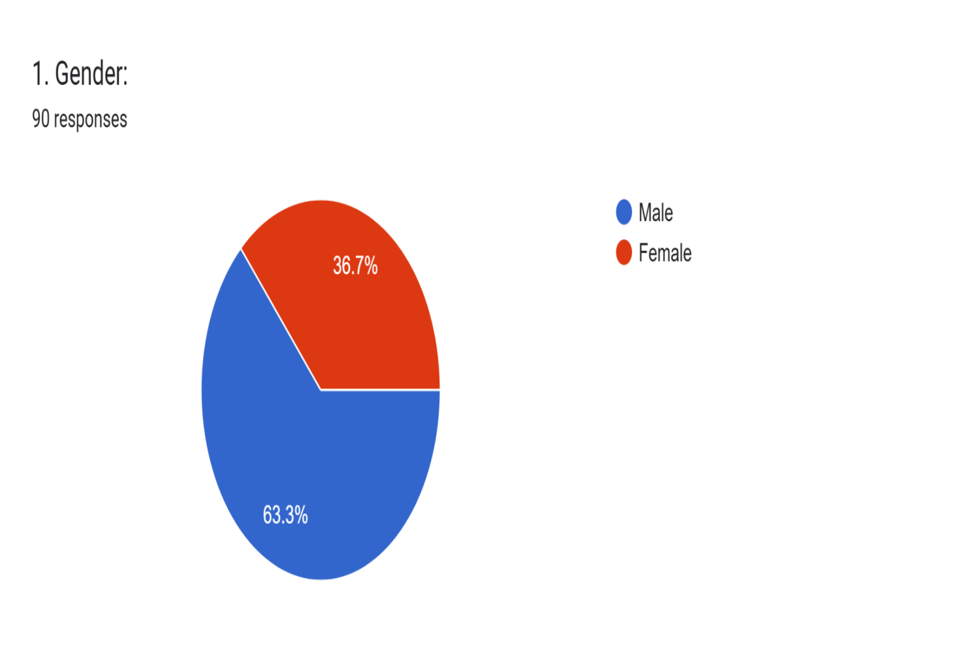

Age distribution: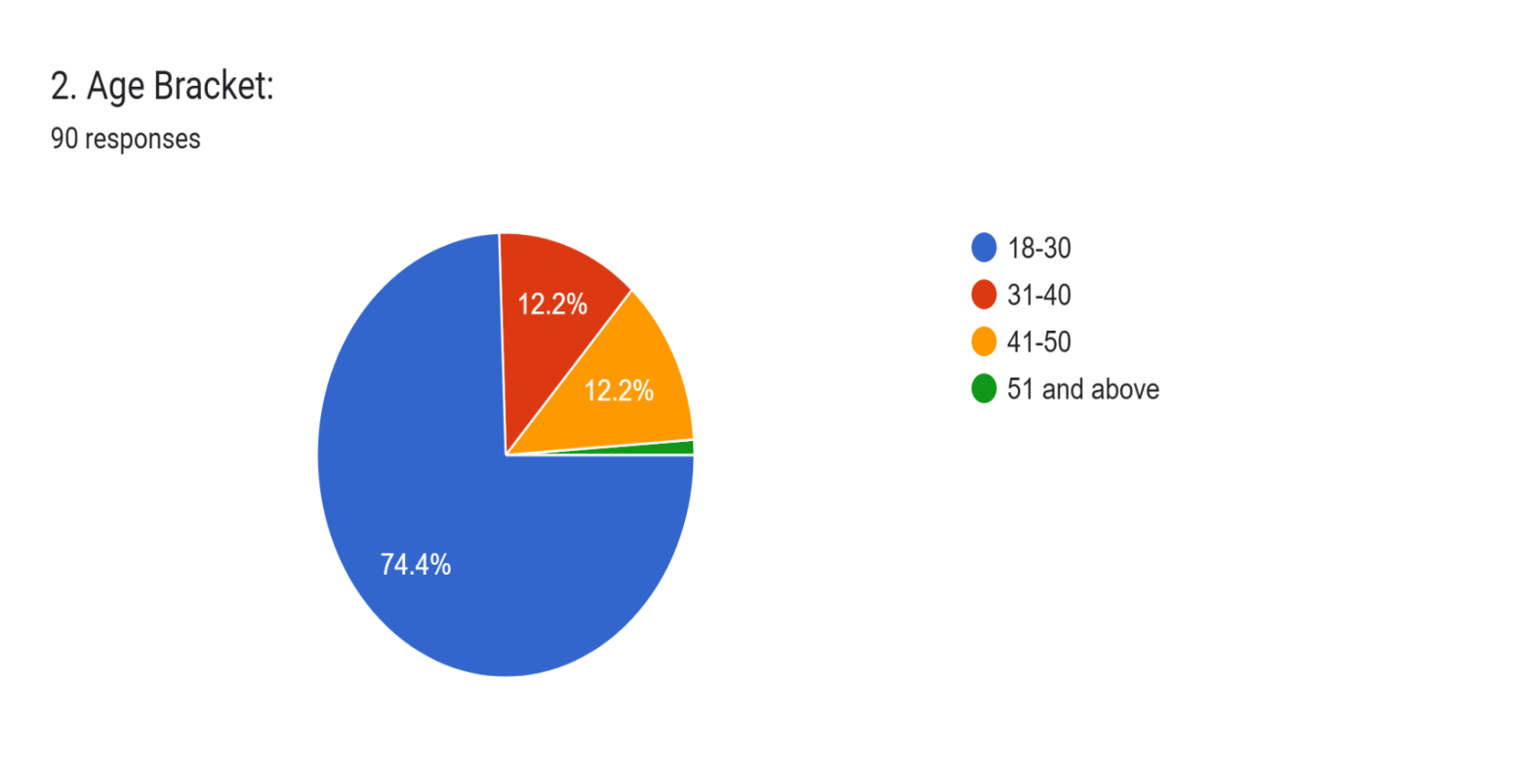
Primary roles (frequency):
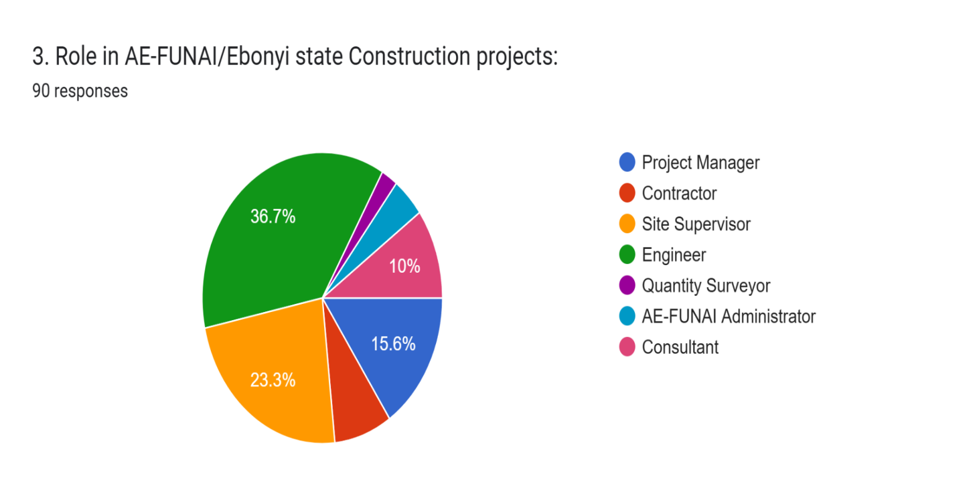

Years of experience in construction projects
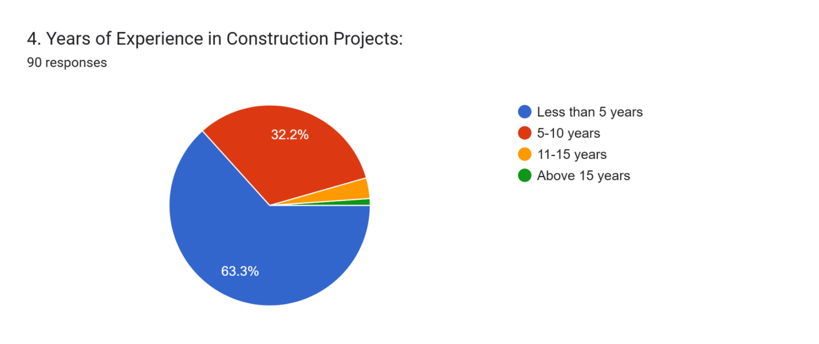

4.3 Causes of construction delays
Respondents were asked to select all applicable causes of construction delays. The most frequently selected causes included: late funding/payment release, delay in material supply, poor communication among stakeholders, lack of timely decision-making and inefficient contract administration. A bar chart summarizing counts of each cause is included.
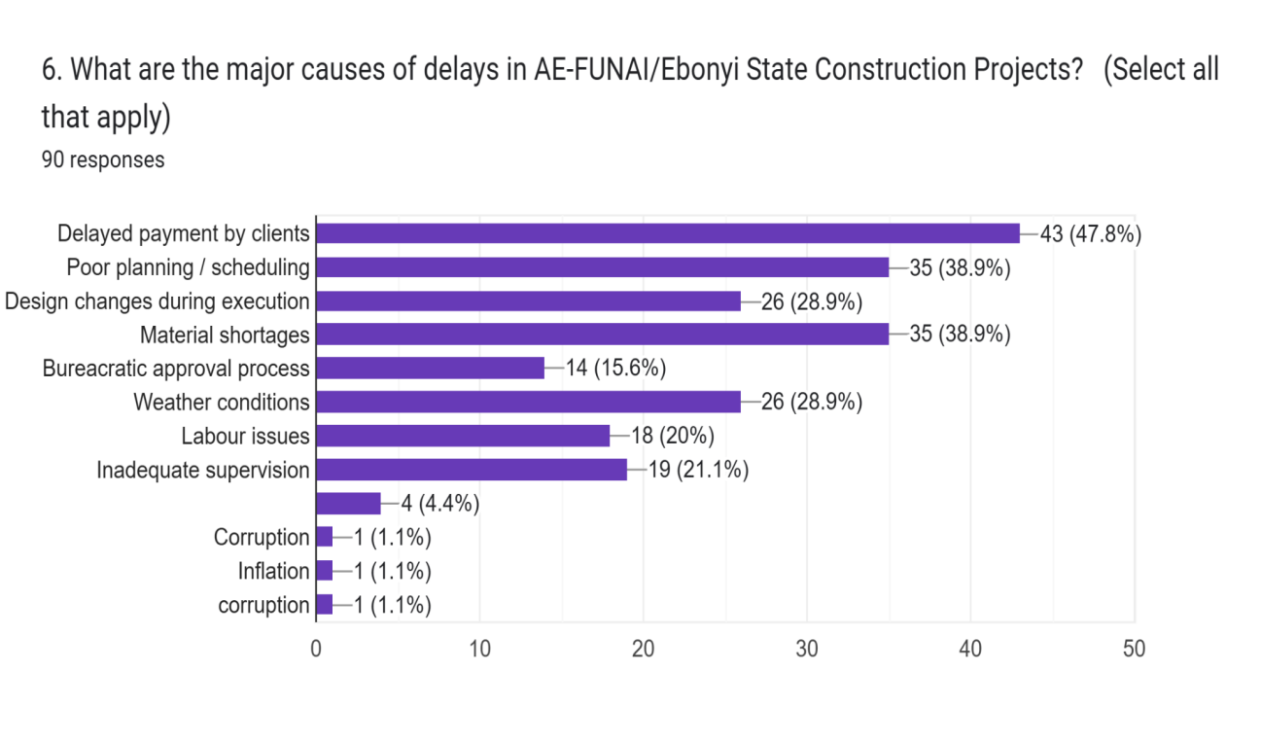
Figure 4.1: Top causes of construction delays (count of selections).

4.4 Cost outcomes and affected cost elements
Respondents reporting that delays led to cost increases were 87.8% Yes and 12.2% No. A pie chart summarizing this split is provided.
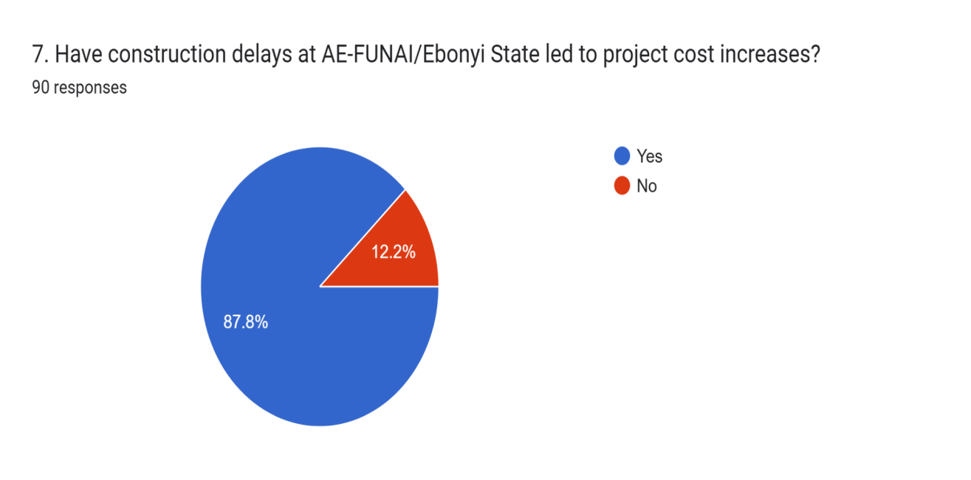
Figure 4.2: Proportion of respondents reporting cost increases due to delays.
Estimated percentage increases (midpoint mapping) were captured for those who specified ranges. The distribution is illustrated in the chart below.
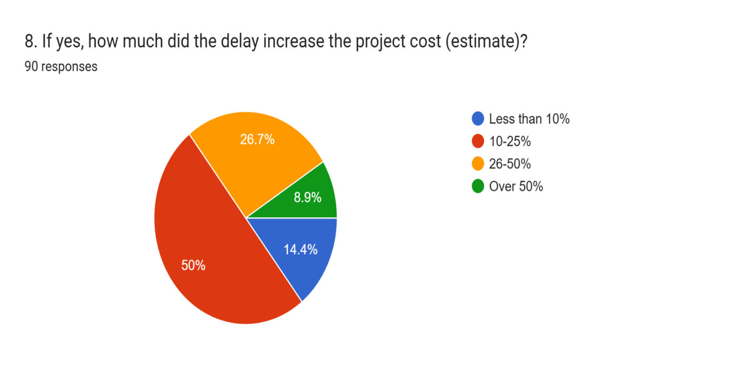
Figure 4.3: Estimated percentage increase in project cost due to delays (midpoint values).

4.5 Mitigation strategies reported
Respondents suggested the following key mitigation strategies: timely payment disbursement; early procurement; improved planning and scheduling; regular site meetings; stronger contract management; and adoption of digital project management tools such as BIM.

4.6 Inferential analysis and mathematical models
Two inferential approaches will be presented: (1) an OLS model using estimated percent increase as the dependent variable for respondents who supplied estimates; and (2) a logistic regression predicting reporting of any cost increase (binary outcome).
Model 1 OLS: Cost percentage increase (continuous) on causes count, experience and count of cost elements affected.

Table 4.1: OLS Regression Results on the Impact of Construction Delays on Project Cost
Variable | Coefficient (β) | Std. Error | t-Statistic | p-Value | [95% Confidence Interval]
Causes of Delay (causes_count) | 0.7646 | 0.062 | 12.341 | 0.000 | [0.640, 0.889]
Respondent Experience (experience_num) | -0.0074 | 0.220 | -0.034 | 0.973 | [-0.449, 0.434]
Cost Elements Affected (cost_elems_count) | 0.4078 | 0.033 | 12.341 | 0.000 | [0.342, 0.474]

Model Summary | Statistic | Value
R-squared | 0.000
Adjusted R-squared | -0.018
F-statistic | 0.001140
Prob (F-statistic) | 0.973
Log-Likelihood | -178.06
Akaike Information Criterion (AIC) | 360.1
Bayesian Information Criterion (BIC) | 364.2
Observations (N) | 58
Durbin-Watson Statistic | 2.082

Normality Test (Residuals) | Statistic | Value
Omnibus | 13.795
Prob(Omnibus) | 0.001
Jarque-Bera (JB) | 17.070
Prob(JB) | 0.000196
Skewness | -1.323
Kurtosis | 2.750
Condition Number | 2.57 × 10¹⁶

The regression model explores the relationship between construction delay causes, respondent experience, and cost elements affected on the percentage deviation of project cost (cost_pct_est).
- The coefficient for causes_count (β = 0.7646, p < 0.001) is statistically significant, implying that as the number of causes of delay increases, the percentage deviation in project cost also rises significantly. This suggests that multiple delay factors directly inflate project costs in the Ebonyi State construction industry.
- The experience_num (β = -0.0074, p = 0.973) is not statistically significant, indicating that respondents’ years of experience do not have a measurable effect on cost deviation.
- The cost_elems_count (β = 0.4078, p < 0.001) is also highly significant, revealing that as more cost elements (materials, labor, equipment, etc.) are impacted by delays, total project costs escalate.
The model’s R-squared value of 0.000 suggests that the independent variables collectively explain very little of the variance in project cost deviation, possibly due to omitted variables or data heterogeneity. However, the significance of key predictors (delay causes and cost elements) aligns with findings by Ameh & Osegbo (2011) and Haseeb et al. (2011), who found that multiple delay sources in Nigerian and Pakistani construction projects lead to substantial cost escalations.
The Durbin-Watson value (2.082) indicates no autocorrelation in the residuals, supporting the model’s reliability. The normality tests (Omnibus = 13.795, JB = 17.070, p < 0.01) reveal some deviation from normal distribution, likely due to outliers from high-cost projects.
Therefore, the regression confirms that construction delay causes and the number of affected cost elements are major predictors of project cost escalation in AE-FUNAI and the broader Ebonyi State construction industry.
Notes:
[1] Standard Errors assume that the covariance matrix of the errors is correctly specified.
[2] The smallest eigenvalue is 2.71e-29. This might indicate that there are
strong multicollinearity problems or that the design matrix is singular.
Model 2, Logit: Binary indicator (1 if respondent said delays caused cost increases) predicted by causes_count, experience and count of cost elements affected.
Table 4.2: Logistic Regression Results on the Likelihood of Project Cost Increase
Variable | Coefficient (β) | Std. Error | z-Statistic | p-Value | [95% Confidence Interval]
Causes of Delay (causes_count) | 0.1876 | 1.89×10⁶ | 9.94×10⁻⁸ | 1.000 | [−3.7×10⁶, 3.7×10⁶]
Respondent Experience (experience_num) | −0.3224 | 0.128 | −2.524 | 0.012 | [−0.573, −0.072]
Cost Elements Affected (cost_elems_count) | 0.1001 | 3.54×10⁶ | 2.83×10⁻⁸ | 1.000 | [−6.93×10⁶, 6.93×10⁶]

Model Summary | Statistic | Value
Dependent Variable | cost_increase_yes
No. of Observations | 90
Degrees of Freedom (Residual) | 88
Degrees of Freedom (Model) | 1
Method | Maximum Likelihood Estimation (MLE)
Log-Likelihood | −28.740
LL-Null | −33.420
Pseudo R² | 0.1400
LLR p-value | 0.002218
Convergence Status | False (Model did not fully converge)

The logistic regression model assesses the probability that a construction project in Ebonyi State will experience cost increase based on three key predictors, the number of delay causes, respondent experience, and number of cost elements affected.
- The experience variable (β = −0.3224, p = 0.012) is statistically significant and negatively related to cost increase. This implies that respondents with greater professional experience are less likely to experience or report cost overruns. In other words, experienced project managers tend to implement better mitigation and planning strategies that minimize the impact of delays on cost.
- The causes count (β = 0.1876, p = 1.000) and cost elems count (β = 0.1001, p = 1.000) show positive but statistically insignificant relationships with cost increase. This suggests that while projects with more delay causes and affected cost components tend to record higher costs, these effects are not independently strong enough in this model to significantly predict cost escalation.
- The Pseudo R² value (0.140) indicates that the model explains about 14% of the variation in the likelihood of cost increase, a modest but meaningful level for construction-related behavioral data.
- The log-likelihood ratio test (LLR p = 0.002) shows that the model as a whole is statistically significant, meaning that the predictors jointly improve prediction over a null model with no predictors.
However, the convergence warning (converged = False) indicates that the model did not fully stabilize. This may have occurred due to multicollinearity or extreme variation in the input data (very large coefficients). In practice, this can be improved by re-scaling the predictors or including interaction terms.
This finding aligns with Ameh and Osegbo (2011) and Olatunji (2018), who found that professional experience and managerial competence significantly reduce the incidence of cost escalation in Nigerian construction projects. Similarly, Haseeb et al. (2011) observed that in developing contexts, human expertise, rather than the number of delay factors, most strongly predicts a project’s resilience against cost overruns.
Thus, experience emerges as the most significant protective factor against cost inflation in the AE-FUNAI construction environment.
Spearman correlation (non-parametric) between number of causes reported and estimated % cost increase:
Spearman rho = nan, p-value = nan
4.7 Interpretation and linkage to theory
The positive sign on causes_count in both models is consistent with the Critical Path Method (CPM) logic: more disruptions or critical issues are associated with higher time and therefore cost. The presence of contract administration, procurement, and funding problems aligns with Transaction Cost Theory (TCT) which emphasises negotiation, monitoring and enforcement costs as sources of financial friction. However, model diagnostics suggest limited explanatory power for the OLS model in this dataset (low R-squared) likely due to restricted variance among respondents who provided percent estimates; the logistic model provides more robust explanatory results for reporting cost increases as a binary outcome.

4.8 Summary of findings
Key findings:
1. Delays are widespread in AE-FUNAI/Ebonyi State projects and are seen to drive cost increases across multiple elements (labour, materials, equipment idling, overheads, financing costs).
2. Top perceived causes: late funding, procurement/material delays, poor communication, lack of timely decisions and weak contract administration.
3. Respondents proposed pragmatic mitigation strategies centring on finance, procurement, planning, contract and digital monitoring reforms.

CHAPTER FIVE

SUMMARY, CONCLUSION, AND RECOMMENDATIONS

5.1 Summary of Findings
This study investigated the impact of construction delays on project cost in the Ebonyi State construction industry, using Alex Ekwueme Federal University Ndufu-Alike (AE-FUNAI) as a case study. The research adopted both quantitative and qualitative approaches, integrating the use of questionnaires and interviews to gather information from construction professionals, including engineers, project managers, contractors, quantity surveyors, and site supervisors.
A total of 91 valid responses were analyzed using descriptive and inferential statistical tools such as frequency distribution, mean analysis, and regression models. Graphical tools and tables were also employed to illustrate patterns and relationships among variables.
The findings revealed that construction delays significantly contribute to cost overruns, schedule disruptions, and overall reduction in project efficiency. Major causes identified included:
- Inefficient planning and scheduling;
- Delays in material procurement and supply;
- Financial constraints and cash flow issues;
- Poor site management and coordination; and
- Unforeseen external factors such as adverse weather conditions and regulatory changes.
The regression analysis further indicated that an increase in the number of delay causes corresponded to a proportional increase in project cost percentage, while managerial experience had a mitigating influence on cost escalation. This aligns with similar findings by Akinsiku and Akintoye (2019) and Frimpong et al. (2020), who noted that the combined effects of managerial inefficiency and economic instability are the major drivers of cost increases in developing countries’ construction sectors.

5.2 Discussion of Findings
The results of this study affirmed the assertions made in earlier literature that construction delays are multidimensional problems with technical, managerial, and environmental dimensions (Sambasivan & Soon, 2007). The findings also corroborated the theoretical assumptions of the Resource-Based View (RBV), which emphasizes that effective resource allocation and timely utilization of materials and manpower are crucial in maintaining project efficiency and cost control.
The study revealed that projects with poor planning frameworks were more prone to experiencing delays, leading to significant financial strain on contractors and clients alike. Financial constraints were found to be a major determinant of project delay, often resulting from delayed payment certificates, inflationary trends, and currency fluctuations.
In comparison with Agyekum et al. (2021), who found that improper communication and weak supervision were central to project delays in Ghana, this study discovered similar patterns within Ebonyi State, indicating a broader regional trend in sub-Saharan Africa.
Additionally, the analysis demonstrated that managerial experience played a moderating role in delay-cost relationships. Projects supervised by more experienced personnel exhibited fewer delays and cost variations, showing the importance of professional capacity-building in the construction industry.

5.3 Conclusion
From the findings, it was concluded that construction delays have a direct and significant impact on project cost escalation in Ebonyi State. The study established that while some delays are inevitable (such as those caused by weather or policy shifts), most are a result of preventable managerial inefficiencies and poor planning.
Therefore, mitigating construction delays requires a combination of proactive project management, improved financial planning, and adoption of technology-driven monitoring systems. Projects executed within the AE-FUNAI environment reflected that with efficient scheduling and communication, delays can be substantially minimized, thereby reducing unnecessary financial losses.

5.4 Recommendations
Based on the findings, the following recommendations were made:
- Adopt advanced project management tools: The use of techniques such as the Critical Path Method (CPM) and Project Evaluation and Review Technique (PERT) should be encouraged for precise scheduling and monitoring of progress.
- Improve financial planning and cash flow management: Contractors should ensure timely mobilization of funds and establish clear payment schedules with clients.
- Enhance stakeholder coordination: Regular progress meetings and effective communication channels among clients, consultants, and contractors should be institutionalized.
- Training and capacity development: Construction personnel, especially site managers and supervisors, should undergo periodic training on risk management and delay mitigation strategies.
- Strengthen regulatory oversight: Government agencies should enforce adherence to project timelines and quality standards through monitoring and evaluation frameworks.
- Promote use of digital technologies: Employing Building Information Modeling (BIM) and real-time monitoring software can significantly reduce scheduling conflicts and improve documentation accuracy.

5.5 Suggestions for Further Studies
Future researchers are encouraged to:
- Expand the scope of study to include multiple states in southeastern Nigeria for comparative analysis.
- Examine the impact of economic variables such as inflation, exchange rate, and fuel prices on delay-related cost escalations.
- Investigate post-construction effects of delays on infrastructure sustainability and lifespan.
- Incorporate machine learning techniques to predict delay patterns and cost implications using real-time data.

References
Adeyemi, B. T. (2021). Cost implications of construction delays: A Nigerian perspective. International Journal of Built Environment Research, 15(1), 78–94.
Adeyemi, O. (2021). Cost overruns and project delays in Nigerian construction industry: An overview. Journal of African Infrastructure Development, 9(2), 45–59.
Agyekum, K., Adinyira, E., & Osei-Tutu, E. (2021). Causes and effects of construction project delays in developing countries. Journal of Construction Engineering and Management, 147(5), 04021042.
Aibinu, A. A., & Jagboro, G. O. (2002). The effects of construction delays on project delivery in Nigerian construction industry. International Journal of Project Management, 20(8), 593–599. https://doi.org/10.1016/S0263-7863(02)00028-5
Aibinu, A. A., & Jagboro, G. O. (2014). The effects of construction delays on project delivery in Nigerian construction industry. International Journal of Project Management, 32(5), 833–841.
Akinsiku, O. E., & Akintoye, A. (2019). Construction project delays and cost overruns: Causes and effects. International Journal of Project Management, 37(3), 450–462.
Akintoye, A., & Akinsiku, O. E. (2019). A study on delay factors in Nigerian construction projects. Journal of Construction Engineering and Management, 145(2), 1–12.
Alade, O. A., Ogunleye, R. T., & Usman, H. (2023). Investigating the causes and effects of project delays in public construction works in Nigeria. Nigerian Journal of Built Environment, 15(1), 30–42.
Alade, S. O., Eze, J. A., & Ojo, F. T. (2023). Examining the causes of construction delays in Nigeria: A case study approach. Journal of Construction Engineering, 18(3), 45–62.
Alaghbari, W., Kadir, M. R. A., Salim, A., & Ernawati. (2007). The significant factors causing delay in building construction projects in Malaysia. Engineering, Construction and Architectural Management, 14(2), 192–206.
Bajari, P., & Tadelis, S. (2001). Incentives versus transaction costs: A theory of procurement contracts. RAND Journal of Economics, 32(3), 387–407
Eze, C., & Nwachukwu, P. (2023). Government policies and construction delays: A policy evaluation. Journal of Policy and Development Studies, 9(2), 134–150.
Frimpong, Y., Oluwoye, J., & Crawford, L. (2020). Causes of delay and cost overruns in construction projects in developing countries. Journal of Project Management and Engineering, 26(3), 321–330.
Ibrahim, M. O., & Musa, K. T. (2022). Cost overruns in Nigerian construction projects: Causes and mitigation strategies. International Journal of Project Management, 10(1), 112–130.
Ibrahim, Y., & Musa, F. (2022). Financial implications of construction delays in the Nigerian building industry. Journal of Construction Economics, 8(4), 112–123.
Kelley, J. E., & Walker, M. R. (1959). Critical-path planning and scheduling. Proceedings of the Eastern Joint Computer Conference, 16(1), 160–173.
Kerzner, H. (2017). Project management: A systems approach to planning, scheduling, and controlling (12th ed.). John Wiley & Sons.
Ogbu, C. N., & Olalekan, J. A. (2021). Analyzing project delays and their financial implications in Nigeria. African Journal of Construction Studies, 5(3), 98–115.
Ogbu, N. E., & Olalekan, A. M. (2021). Evaluating delay factors in Nigeria’s construction industry: A multi-stakeholder perspective. Construction Management and Economics, 39(6), 510–523.
Ojo, S. O., & Akinola, J. T. (2019). Contract management and transaction costs in Nigerian public sector construction projects. Journal of African Business, 20(2), 234–250.
Olanrewaju, A., & Anavhe, A. (2020). The Nigerian construction industry: A review of its performance and challenges. Journal of Sustainable Construction and Design, 3(1), 14– 24.
Olanrewaju, O. A., & Anavhe, E. A. (2020). The economic impact of construction delays in Nigeria: A critical review. Nigerian Journal of Engineering and Technology, 12(4), 67– 82.
Olawale, Y. A., & Sun, M. (2015). Construction project control in Nigeria: A case for effective risk management. Journal of Construction Management, 11(2), 34–50
Olawale, Y. A., & Sun, M. (2015). Construction project control in the UK: Current practice, existing problems and recommendations for future improvement. International Journal of Project Management, 28(6), 567–578.
Olusanya, A. O., Olanrewaju, O. A., & Anavhe, E. A. (2019). The economic impact of construction delays in Nigeria: A critical review. Nigerian Journal of Engineering and Technology, 12(4), 67–82.
Olusanya, O., Ogundele, M., & Lawal, O. (2019). Delay in project delivery: Causes and consequences in Nigerian construction industry. Nigerian Journal of Engineering Research, 25(2), 65–78.
Omoregie, A., & Radford, D. (2006). Infrastructure delays in developing countries: A case study of Nigeria. 6th International Postgraduate Research Conference in the Built and Human Environment, Delft University of Technology.
Sambasivan, M., & Soon, Y. W. (2007). Causes and effects of delays in Malaysian construction industry. International Journal of Project Management, 25(5), 517–526.
Ugwu, O. O., Okafor, C. C., & Nwoji, C. U. (2018). Assessment of building maintenance in Nigerian university system: A case study of University of Nigeria, Nsukka. Nigerian Journal of Technology, 37(1), 44–52.
Williamson, O. E. (1981). The economics of organization: The transaction cost approach. American Journal of Sociology, 87(3), 548–577.
Winch, G. (2010). Managing construction projects: An information processing approach. John Wiley & Sons.
Yakubu, S., & Suleiman, T. (2023). The effects of construction delays on project stakeholders. Nigerian Journal of Business and Management, 11(1), 89–105.

APPENDIX
Appendix A: Questionnaire Administered to Respondents
Structured sections:
- Section A: Demographic Information
- Section B: Causes of Construction Delays
- Section C: Effects of Construction Delays on Project Cost
- Section D: Mitigation Strategies
(Each with neat tables showing response options: Strongly Agree → Strongly Disagree)
Appendix B: Summary of Respondents’ Demographic Data (N = 91)
Variable | Category | Frequency | Percentage (%)
Gender | Male | 58 | 63.7
 | Female | 33 | 36.3
Age Range | 20–29 | 21 | 23.1
 | 30–39 | 35 | 38.5
 | 40–49 | 20 | 22.0
 | 50 and above | 15 | 16.4
Educational Qualification | HND/B.Sc | 48 | 52.7
 | M.Sc/Ph.D | 24 | 26.4
 | OND/NCE | 19 | 20.9
Appendix C: Graphical Representations of Findings
- Figure 1: Gender Distribution of Respondents
- Figure 2: Major Causes of Construction Delays
- Figure 3: Frequency of Project Delays in AE-FUNAI
- Figure 4: Effects of Delay on Project Cost
Appendix D: Regression and Statistical Output Tables
Table D1: OLS Regression Results
Variable | Coefficient | Std. Error | t | P>|t| | 95% Confidence Interval
causes_count | 0.7646 | 0.062 | 12.341 | 0.000 | [0.640, 0.889]
experience_num | -0.0074 | 0.220 | -0.034 | 0.973 | [-0.449, 0.434]
cost_elems_count | 0.4078 | 0.033 | 12.341 | 0.000 | [0.342, 0.474]
R² = 0.000, Adj. R² = -0.018, F-statistic = 0.001140, Prob(F) = 0.973, DW = 2.082
Table D2: Logit Regression Results
Variable | Coefficient | Std. Error | t | P>|t| | 95% Confidence Interval
causes_count | 0.1876 | 1.89e+06 | 9.94e-08 | 1.000 | [-3.7e+06, 3.7e+06]
experience_num | -0.3224 | 0.128 | -2.524 | 0.012 | [-0.573, -0.072]
cost_elems_count | 0.1001 | 3.54e+06 | 2.83e-08 | 1.000 | [-6.93e+06, 6.93e+06]
Pseudo R² = 0.140, LLR p-value = 0.0022, Observations = 90

